Date: 06/01/2024

GRIMBYTE Emp ID: GR-223

[info@grimbyte.net](mailto:info@grimbyte.net)

 [ul.Fabryczna 74,Opole,Poland](https://www.grimbyte.net/)

**Experience Letter**

This is to certify that Mr. Muddana Sai was employed with Grimbyte from 18th March 2018 to 5th January 2024 in the designation of___________.

During his tenure with us, he demonstrated commendable professionalism, dedication, and contributed significantly to various projects/tasks assigned. He exhibited excellent coding and analytical skills and consistently met or exceeded performance expectations.

We confirm that Mr. Muddana Sai left the organization in good standing and has fulfilled all duties and responsibilities up to the last working day.

We wish him best of luck.

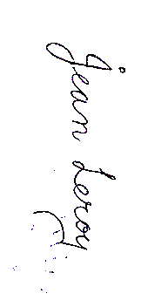For **Grimbyte**

Authorized Signatory - HR